USMENI ISPIT

- Prva grupa pitanja (0 – 10 poena)
1. Football positions
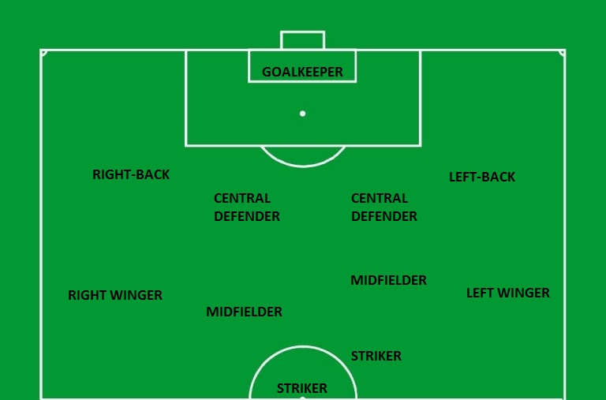

- Druga grupa pitanja (10 – 20 poena)
1. My favourite team/club (3-5 rečenica)
2. My favourite manager (3-5 rečenica)
3. Something about myself as a sportsman (3-5 rečenica)

- Treća grupa pitanja (20 – 30 poena)
1. Do you agree with the statement: Great strikers score more than 20 goals every season? (3-5 rečenica)
2. Do you agree with the statement: There were more great basketball players in the past? (3-5 rečenica)
3. Do you agree with the statement: In the future, more managers are going to come from outside the sport? (3-5 rečenica)

